GRAMMAR
Tick (✓) A, B, or C to complete the sentences.
Example: A What’s in your pocket?
B Two ________.
A key B keyes C keys ✓
1 A What’s in your bag?
B ________.
A A umbrella B An umbrella C Umbrella
2 This is ________ coat.
A me B my C I
3 Where are ________ pens?
A our B ours C we
4 They’re our ________.
A mobile phone B mobile phones C mobiles phones
5 ________ name is Joe. He’s from the USA.
A His B Her C Its
6 Fiona and Sally are sisters. ________ brother’s name is Tom.
A His B Her C Their
7 Are they good ________?
A photo B photos C photoes
8 ________ coats are over there!
A You B Your C Yours
9 Where’s your ________?
A coat big B big coat C a big coat
10 They’re ________.
A talls women B women tall C tall women
11 It’s ________ car.
A a expensive B an expensive C expensive
12 Where are your ________?
A child B childs C children
13 She’s ________ sister.
A Paulas B Paula’s C Paula
14 She is American and this is ________ car.
A its B his C her
15 Are they your ________?
A watch B watchs C watches
16 It’s a ________ car.
A small B our C Jill’s
17 Mr ________ daughter is in Spain.
A Smith B Smiths C Smith’s
18 Her ________ are nice.
A son B sons C son’s
19 It’s a ________.
A good book B book good C book’s good
20 Emily and Tom are ________ children.
A our B ours C our’s

20
VOCABULARY
a Tick (✓) the correct word A, B, or C.
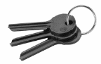
Example:

A bags B keys ✓ C pens
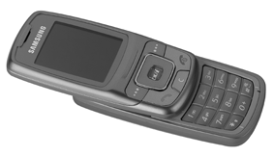
1

A a mobile phone B a watch C an umbrella

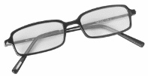
2

A cards B clocks C glasses

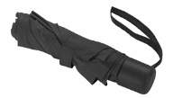
3

A a key B an umbrella C a pen


4

A an ID card B a credit card C a key

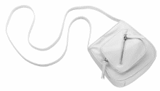
5

A a coat B a board C a bag

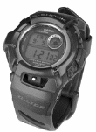
6

A a door B a watch C a window
b Tick (✓) A, B, or C to complete the sentences.
Example: He is my ________.
A brother ✓ B sister C mother
7 His name is Josh. He is my ________.
A husband B daughter C wife
8 Her ________ name is Mike, and he’s 45.
A mother’s B father’s C child’s
9 Kelly is 18. Her ________ are 50.
A fathers B mother C mother and father
10 My ________, Dan and Tim, are very tall men.
A sisters B brothers C daughters
11 Jane is a fantastic girl and Joe is a very nice boy. They are my ________.
A brothers B sisters C friends
12 We have two ________, a boy and a girl.
A sons B childs C children
13 I’m married. I have a ________. She’s two.
A daughter B children C son
14 My brother’s married. His ________’s name is Martha.
A girlfriend B woman C wife
c Tick (✓) A, B, or C to complete the sentences.
Example: That watch is £299. Wow! That’s ________!
A cheap B big C expensive ✓
15 My parents are ________. My mother is 182 cm and my father’s 203 cm.
A tall B long C short
16 He’s a very ________ man. He’s 97.
A long B old C big
17 Your mobile phone’s fantastic. Is it ________?
A late B today’s C new
18 This car is very ________. It has a top speed of 240 kph.
A speed B short C fast
19 These glasses are very ________. They’re only £3.
A small B cheap C long
20 I’m tall but my brother is ________. He’s only 158 cm.
A short B slow C old

20
PRONUNCIATION
a Which word has a different sound? Tick (✓) A, B, or C.
Example: A mother B father ✓ C brother
1 A tall B short C fast
2 A phone B coat C book
3 A door B card C small
4 A wife B friend C nine
5 A slow B long C old
b Which is the stressed syllable? Tick (✓) A, B, or C.
Example: A fantastic B fantastic ✓ C fantastic
6 A expensive B expensive C expensive
7 A umbrella B umbrella C umbrella
8 A dictionary B dictionary C dictionary
9 A credit card B credit card C credit card
10 A holiday B holiday C holiday

10

Grammar, Vocabulary, and Pronunciation total |  | 50

